Corrine Sadler
D597-Data Management
December 14, 2025

Task 1: Relational Database Design and Implementation
Part 1: Design Document
- Scenario 1

- HealthFit Innovations is a rapidly growing company with goals to scale its platform and expand its user base. Since the company is in its early stages, it lacks comprehensive and integrated business data, making it difficult to gain meaningful insights into its user demographics and health trends. By analyzing this data, HealthFit could identify valuable patterns such as correlations between users’ preferred fitness trackers, medical conditions, medications, gender, and age. Currently, data exists in disconnected and unstructured sources, preventing multi-variable analysis- such as examining how medical conditions may relate to device selection or user behavior. To support growth and informed decision making, HealthFit requires a relational database that can centralize these datasets, enforce structure, and create the relationships necessary for deeper analytical insight.
- To solve HealthFit’s problem of fragmented demographic and health data, a relational database implemented in PostgreSQL will be used. Relational database structures allow information to be stored in organized tables and connected through defined relationships, ensuring consistent and precise data retrieval. I propose seven relational tables with PK/FK relationships centered on patients. An Entity Relationship Diagram (ERD) will be developed during the design phase to visually model the required tables, attributes, and relationships before implementation. ERDs are commonly used by database analysts and engineers to define how elements interact and to ensure the structure aligns with organizational needs (Belcic, I., & Stryker, C., (2024). By using a relational database structure supported by an ERD design, HealthFit can centralize data, reduce redundancy, and enable multi-variable analysis that supports decision-making and future scalability.

- The proposed relational database structure directly addresses HealthFit’s current lack of organized and connected data. Centralizing patient demographics, device usage, medical conditions, allergies, medications, and appointment information into related tables, the system eliminates fragmentation and will allow data to be analyzed collectively. Primary and foreign key relationships ensure that information can be accurately linked across tables, enabling the company to identify meaningful patterns, such as how medical needs may influence device preferences or user behavior. Because PostgreSQL supports efficient data querying and scalability, the database will continue to function effectively as HealthFit’s user base grows. Overall, this solution provides the structured, integrated, and accessible data foundation HealthFit needs to support informed decision-making and business expansion.

- The proposed database solution will use HealthFit’s business data by linking patient demographics to their fitness tracker usage and medical information, enabling the organization to perform deeper analysis that was not previously available. By storing data in related fields, the system can identify trends such as correlations between age groups and preferred tracker models. Queries can also be used to track appointment patterns, monitor common allergies, and evaluate product performance based on user health profiles. These insights can drive business strategies such as targeted marketing, device recommendations, and personalized health plans. By transforming raw data into a standardized form, the database will help HealthFit make data-driven decisions that improve patient outcomes and enhance company growth.

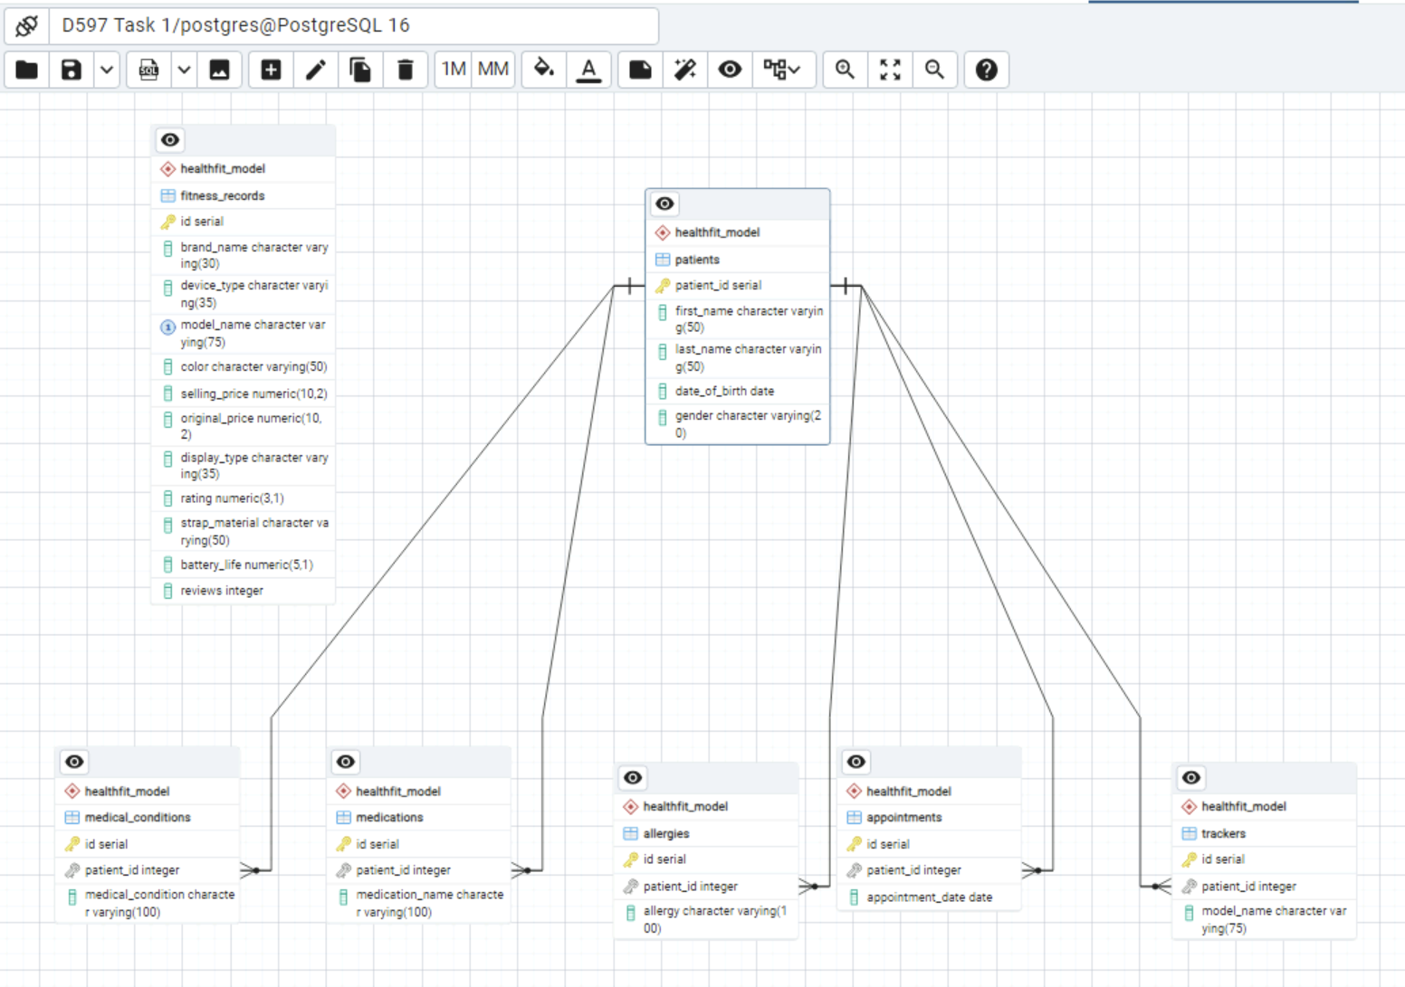
C.
The HealthFit database consists of two relational tables in PostgreSQL: fitness_records and medical_records. While the initial conceptual design explored a more normalized multi-table structure, the implemented database consolidated the dataset into two relational tables to align with the provided CSV data sources and the analytical focus of the project. Together, these tables centralize device information and patient medical profile data to support multi-variable analysis, including device type, age, gender, and medical conditions. The schema applies PostgreSQL data types appropriate to the dataset, including INTEGER for identifiers and counts, VARCHAR for descriptive text fields such as names, conditions, and device labels, and NUMERIC for pricing and rating values.
Each table includes a primary key defined using INTEGER GENERATED ALWAYS AS IDENTITY to ensure entity integrity and uniquely identify each record. The fitness_records.id and medical_records.record_id columns provide stable, system-generated identifiers that support reliable data management and indexing, while remaining independent of analytical join logic.
The fitness_records table functions as a catalog of fitness tracker models and their attributes. The table includes an auto-generated primary key along with descriptive columns such as brand_name, device_type, model_name, color, selling_price, original_price, display_type, rating, strap_material, battery_life, and reviews. Since analytical queries frequently group results by device category and joins records by model name, indexes are applied to device_type and model_name to improve query performance.
The medical_records table stores each patient’s medical profile fields in one record, including patient_id, name, date_of_birth, gender, medical_conditions, medications, allergies, last_appointment_date, and tracker. The tracker column logically links patient records to the appropriate fitness device model in fitness_records via model_name, enabling JOIN-based reporting without enforcing a physical foreign key constraint. To support efficient join and filtering, an index on medical_records.tracker is used alongside the index on fitness_records.model_name, optimizing performance for analytical queries that combine data from both sides.
D.
The proposed database is designed to support both current and future growth as HealthFit expands its user base and business offerings. By storing data in normalized relational tables, the system eliminates duplication and improves query performance, even as more patient and device information is collected. PostgreSQL allows for vertical scaling through additional processing power and storage, while horizontal scaling is supported by options such as partitioning larger tables, including those that store patient medical information. Indexing of primary keys further improves lookup and join operations, ensuring queries remain efficient as data volume increases. Overall, the HealthFit database design provides a scalable foundation that can accommodate future expansion in patient data, device information, and medical records, ensuring long-term usability and performance from the organization.

E.
Due to the HealthFit database storing sensitive patient information, strong privacy and security measures must be implemented to ensure compliance with healthcare privacy standards such as HIPAA. Access to the database should follow the rule of only allowing authorized personnel to view or modify specific data, specifically necessary for their roles. Role-based permissions and secure authentication help prevent unauthorized access. Data must be encrypted when it is stored in the database and when it is being transferred between systems to prevent unauthorized access or interception. Audit logs should track all access and modifications, and regular backups should be maintained for recovery in case of system failures or security incidents. When information must be shared for reporting or analysis purposes, data minimization and anonymization techniques should be used to remove identifying details whenever possible. These practices help preserve patient confidentiality while ensuring the database remains secure, properly managed, and compliant with industry regulations.
Part 2: Implementation
F.
1.
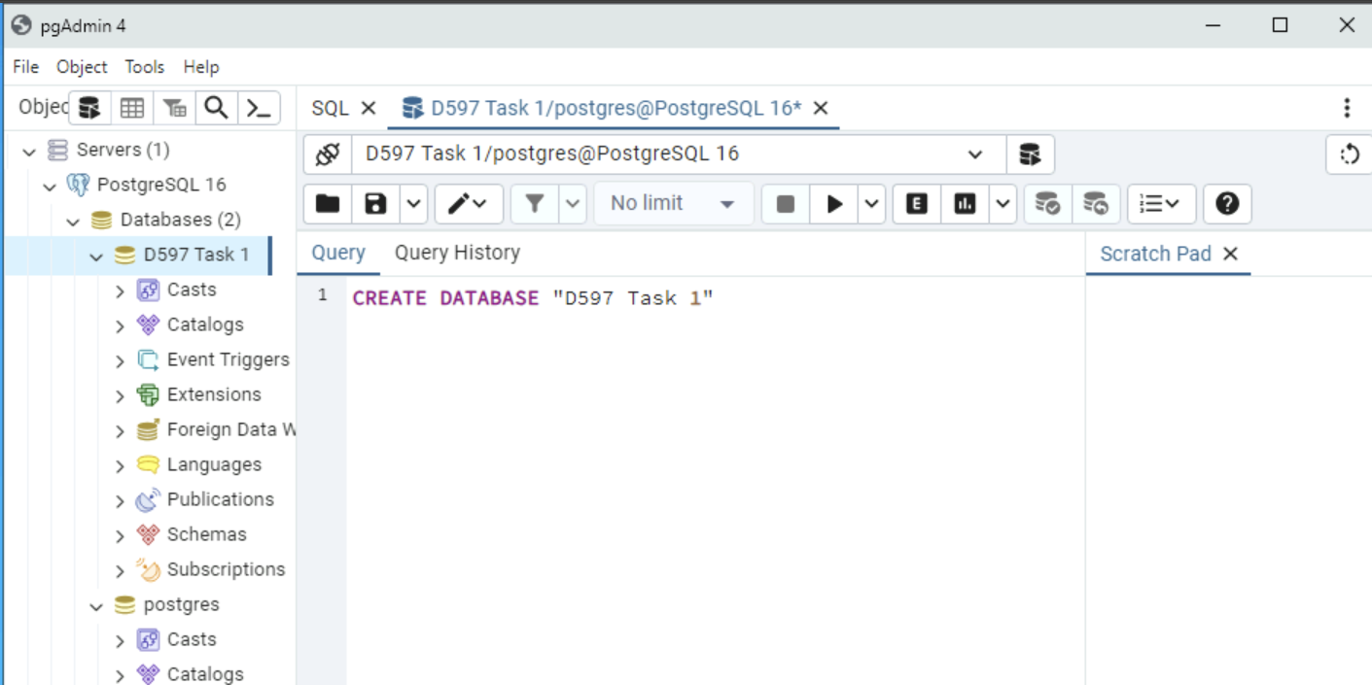
2. Data was imported into the database using SQL scripts that created the tables structures and loaded CSV data, verified through successful query results.
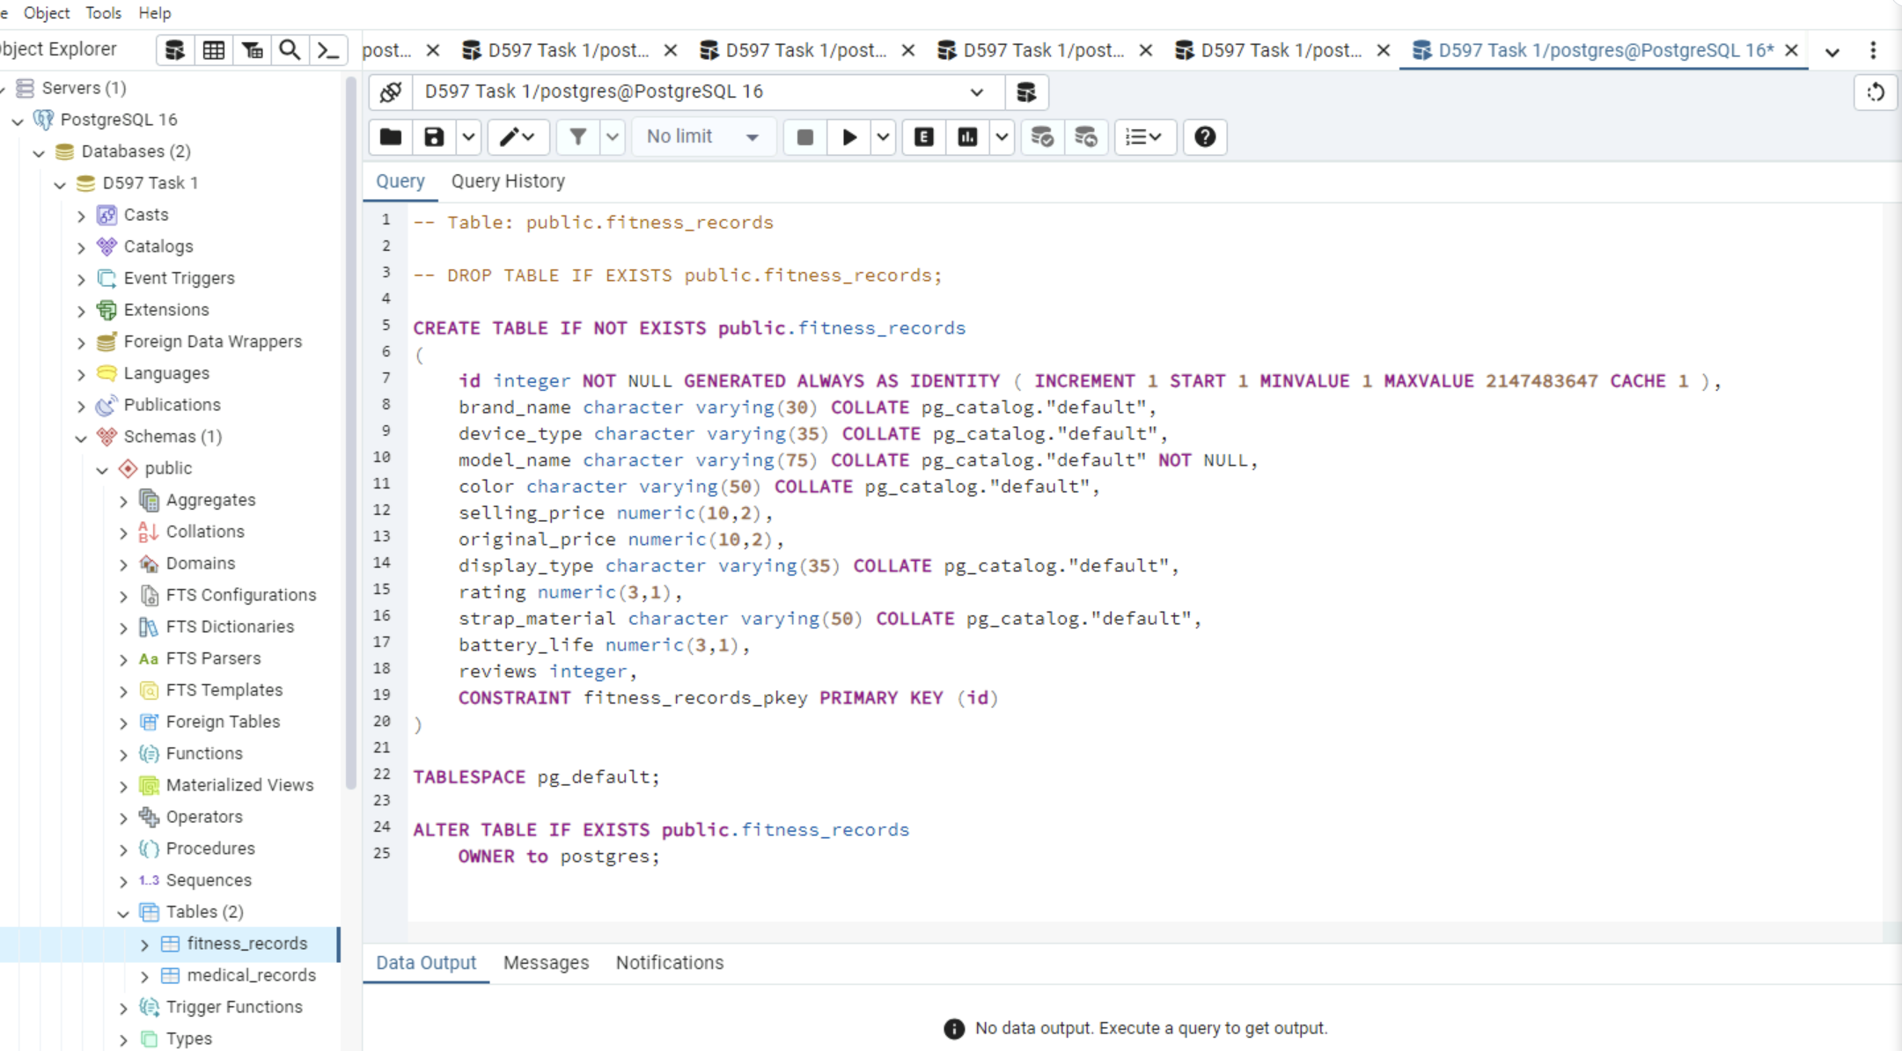
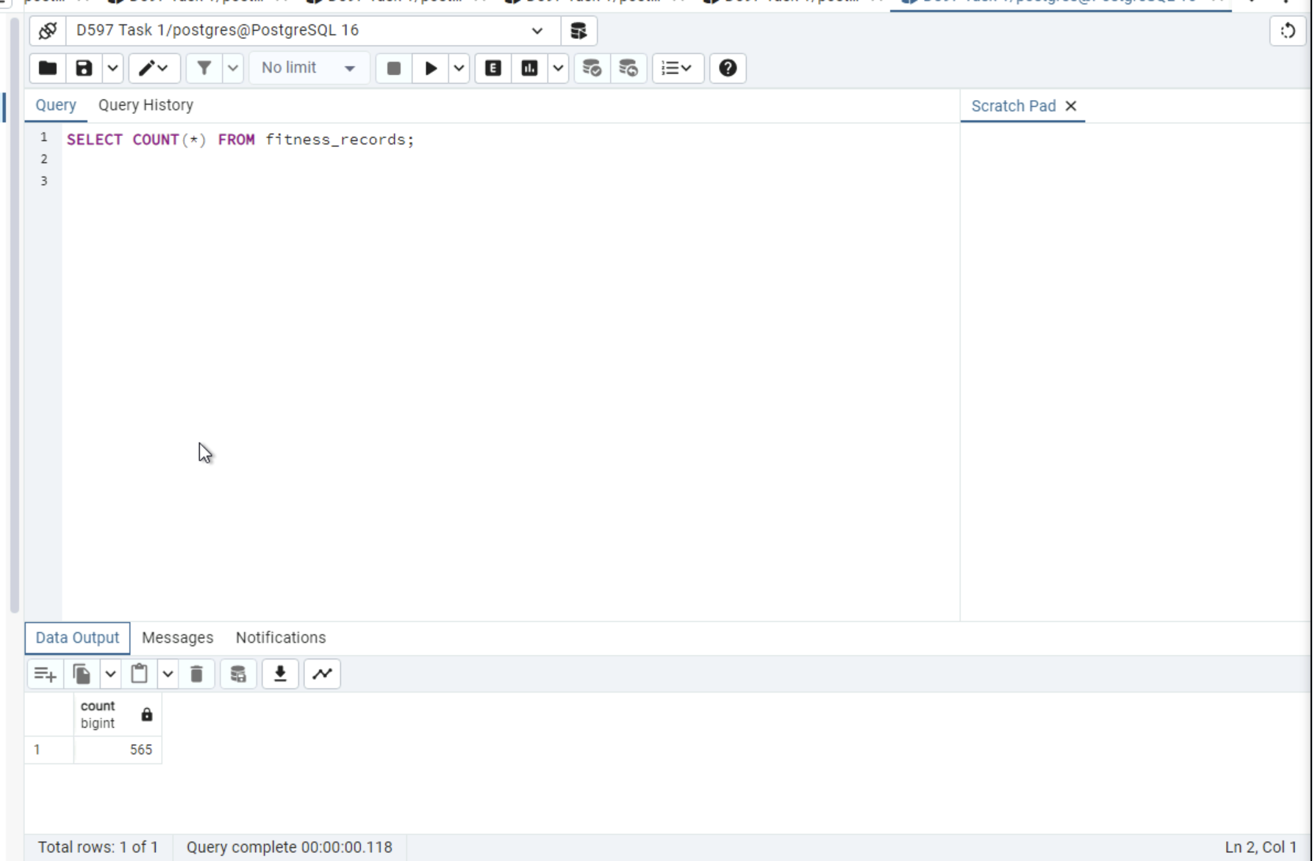

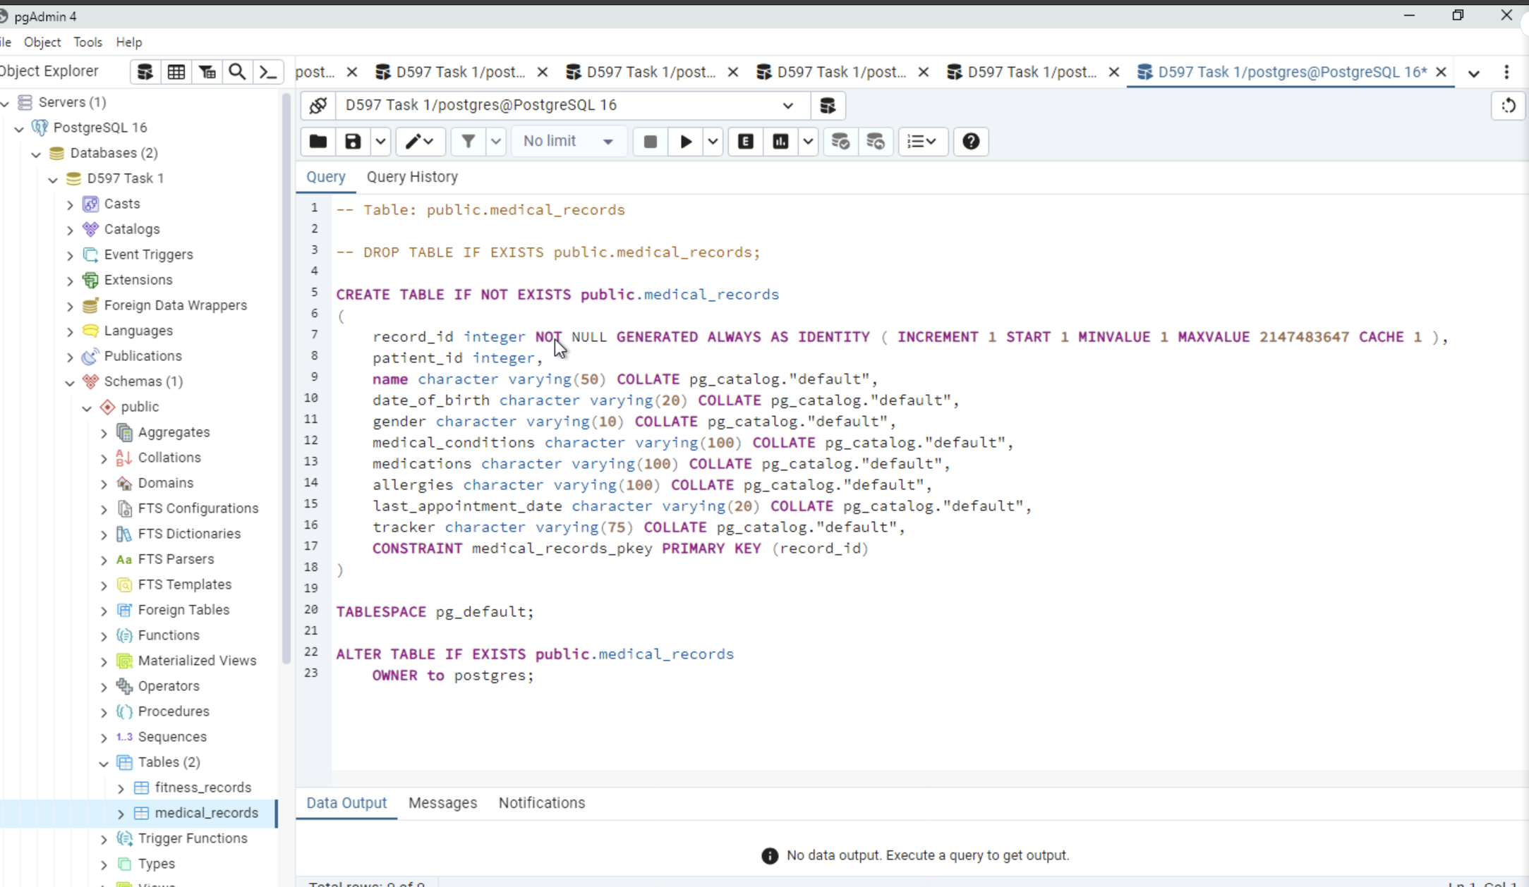
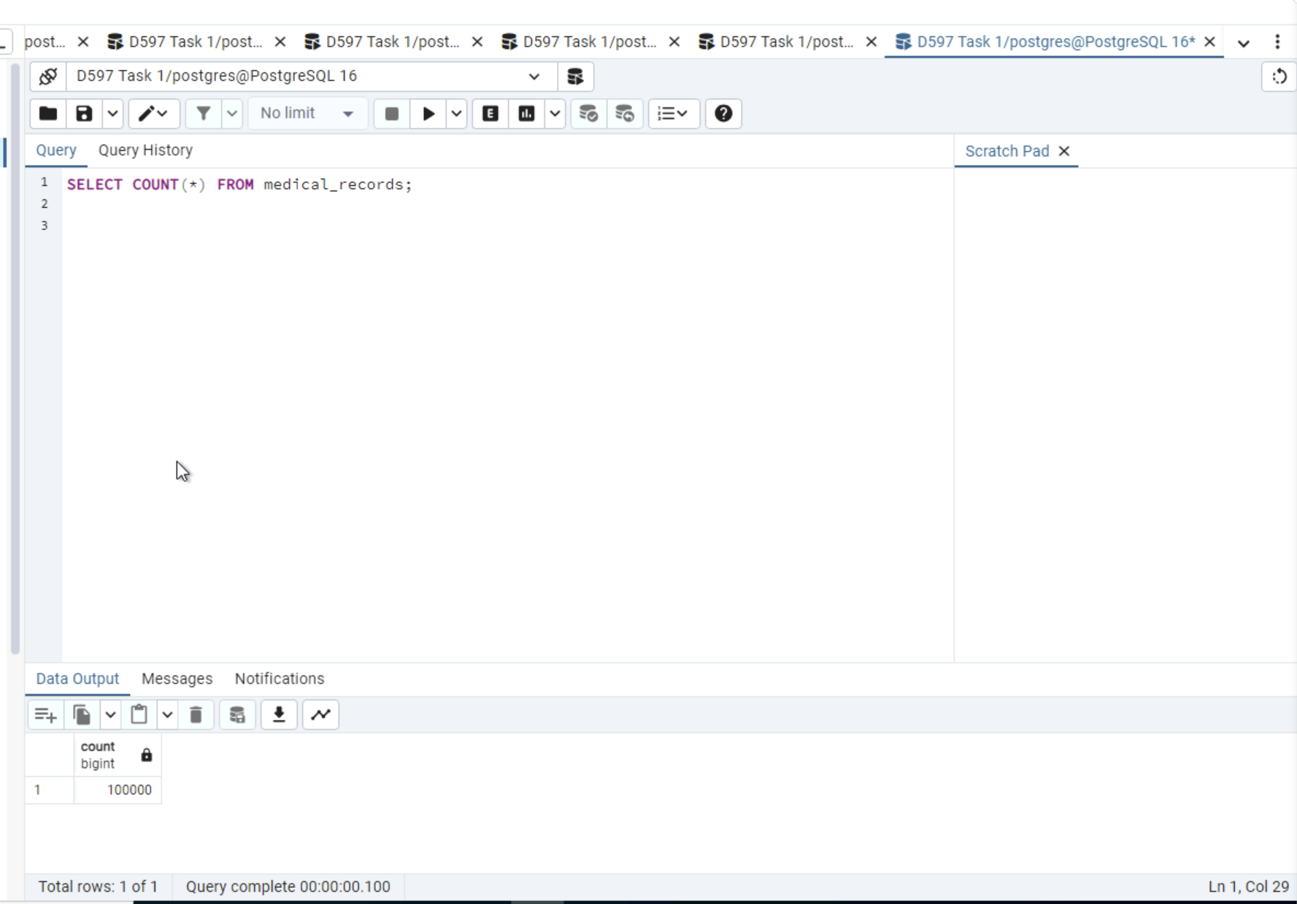
3. Before optimization

Query 1: Purpose
Query 1 analyzes pricing trends across different fitness tracker device types by calculating the average selling price and average original price for each device category. This query supports business analysis by identifying pricing differences between smartwatch and fitness band products.
Before Optimization
Before optimization, the query relied on a sequential scan of the fitness_records table. The execution plan generated by EXPLAIN ANALYZE shows a Seq scan and HashAggregate operation to group results by device type. Since no supporting index existed on the grouping column, PostgreSQL scanned all rows in the table, resulting in a high execution time.

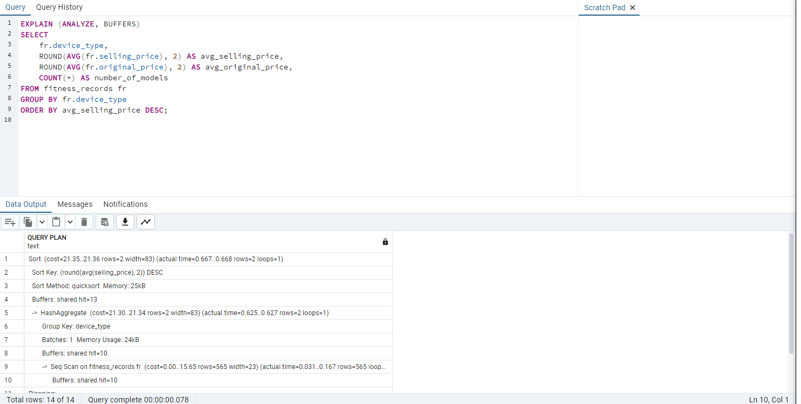
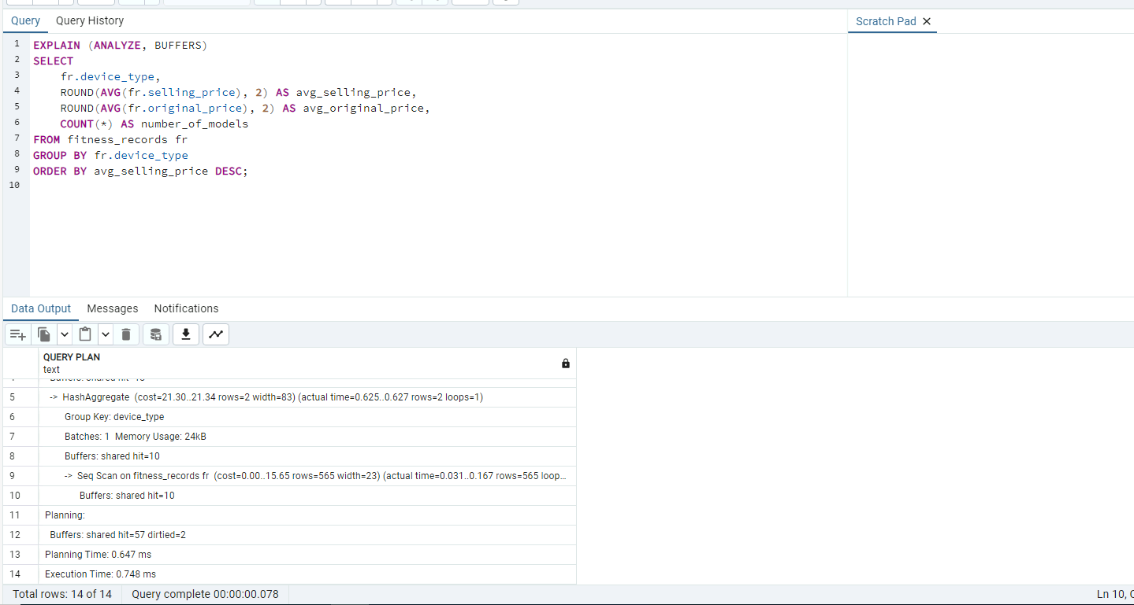
Query 2: Purpose
Query 2 analyzes fitness tracker usage by age group and gender, revealing which demographic groups prefer specific device types. By categorizing patients into age ranges and aggregating usage counts, this query supports business insights related to customer demographics, device adoption trends, and targeted marketing strategies.
Before Optimization
Before optimization, Query 2 relies on sequential scans of both the medical_records and fitness_records tables. The execution plan generated by EXPLAIN ANALYZE shows a Seq Scan on each table followed by a Hash Join to combine patients’ records with device information. Additionally, a HashAggregate operation was required to group results by age group, gender, and device type. Since no indexes existed on the join columns (medical_records.tracker and fitness_records.model_name) or the grouping fields, PostgreSQL was required to scan all rows and perform in-memory hash operations, resulting in a high execution time.
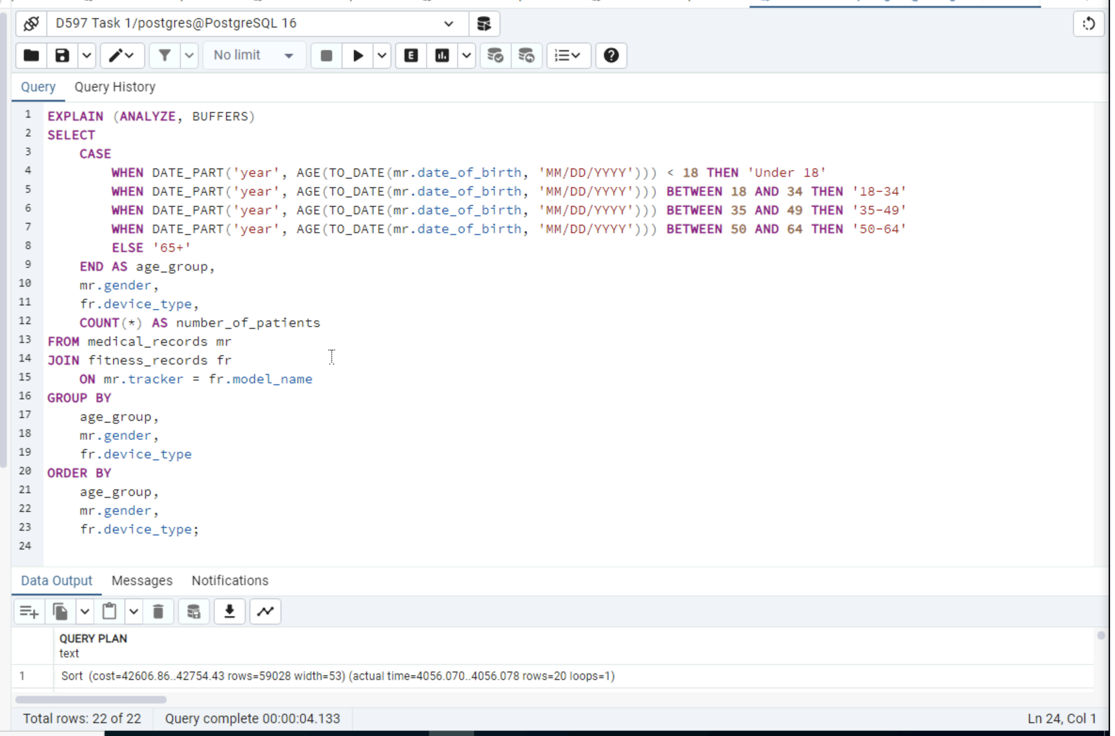
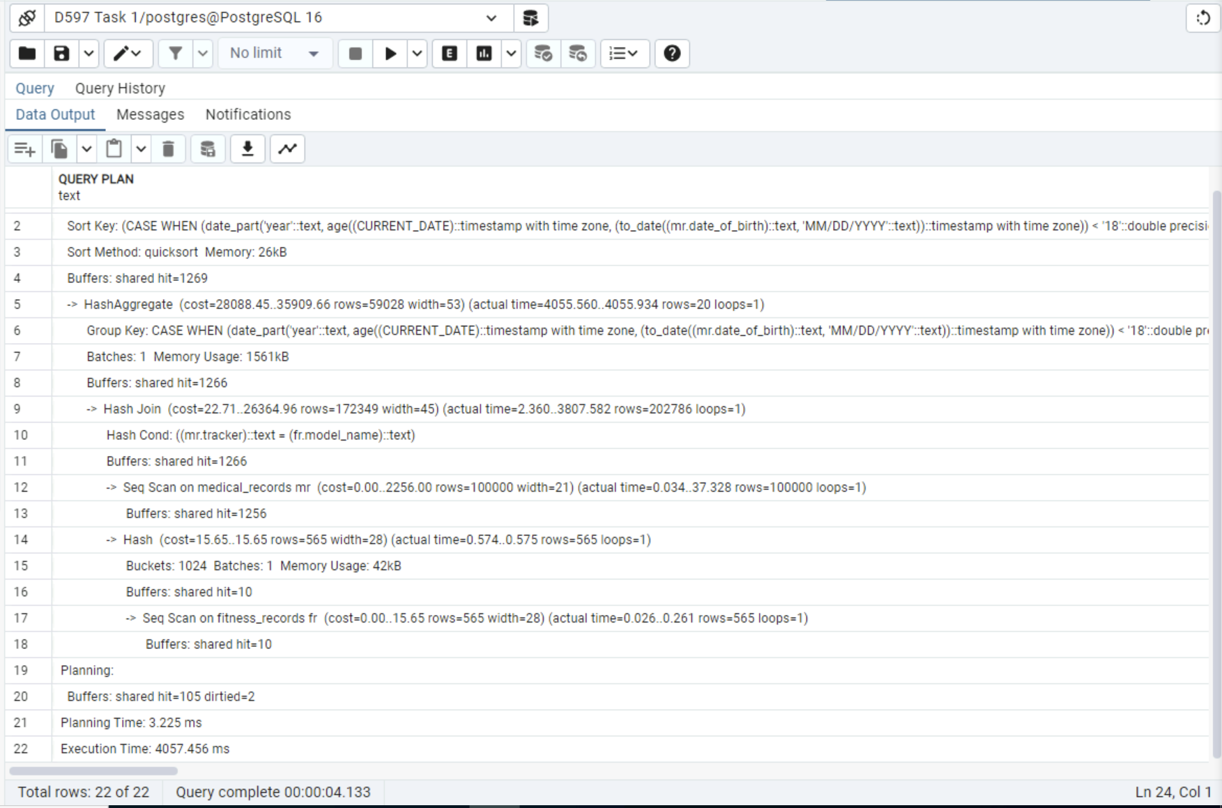
Query 3: Purpose
Query 3 identifies how many patients with specific medical conditions are associated with each tracker device type. The query joins patient medical profiles in medical_records with device information in fitness_records, then groups the results by medical_conditions and device_type to return the top 10 condition/device combinations with the highest patient counts. This supports business analysis by revealing patterns between health conditions and device usage.
Before Optimization
Before optimization, Query 3 performed a join between medical_records and fitness_records using the columns medical_records.track and fitness_records.model_name. The execution plan shows that PostgreSQL must read through large portions of the joined data, then perform aggregation and sorting to produce the final ranked output. The EXPLAIN ANALYZE output shows a GroupAggregate step (grouping mr.medical_conditions and fr.device_type) and a Sort operation on COUNT(*) Desc to support the “top results” requirement. Finally, the query applies a LIMIT 10, but the database still must complete the grouping and sorting work before it can return the top 10 rows. Without supporting indexes on the join columns, PostgreSQL relies on scanning and in-memory operations, which increases total execution time.
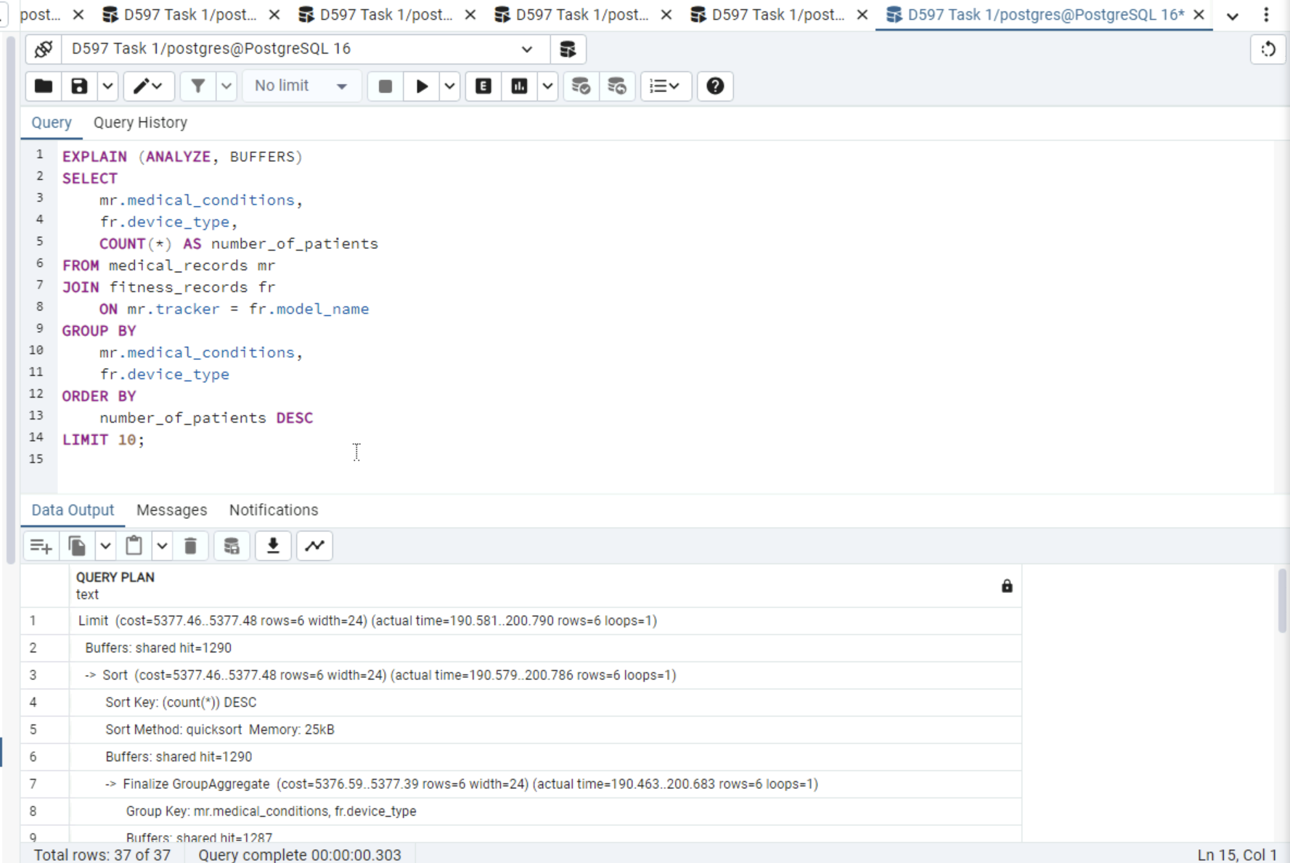
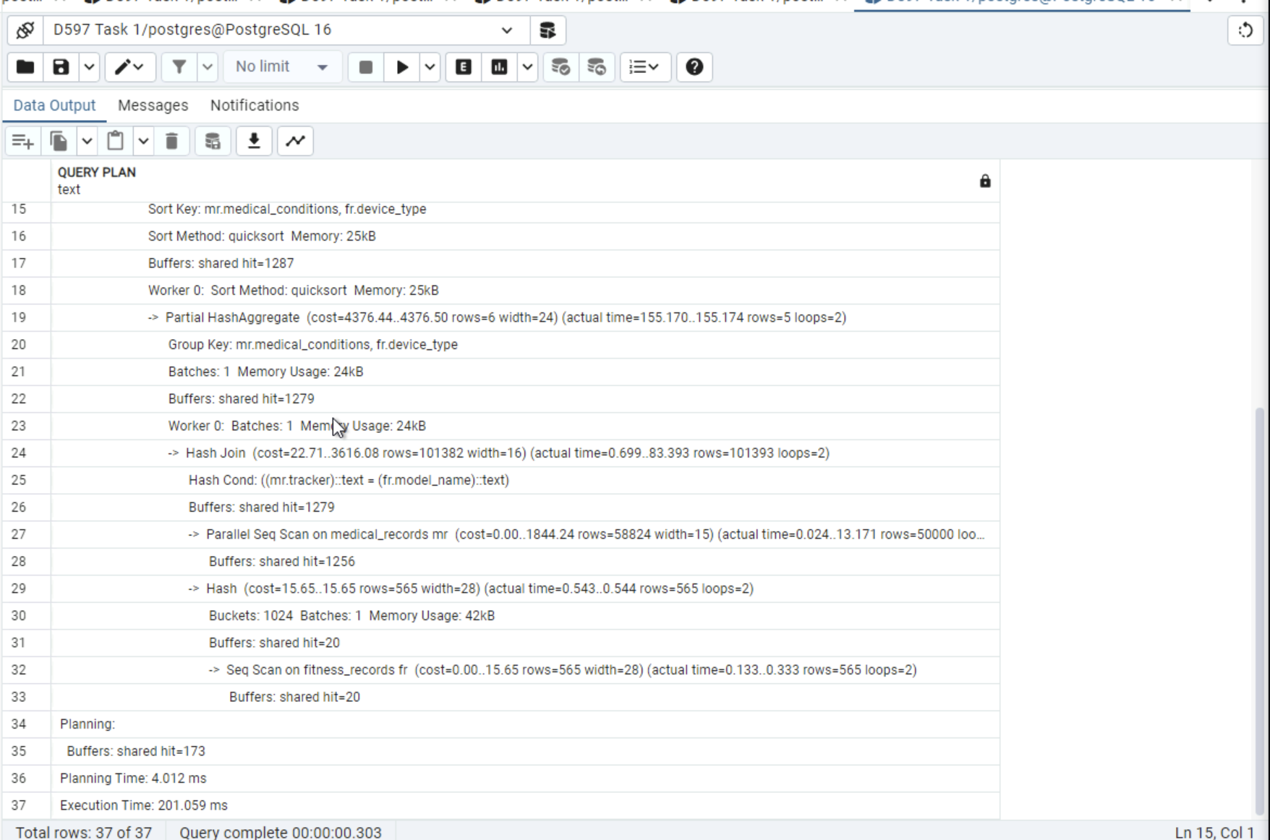
4.
Query performance was optimized by adding indexes beyond PostgreSQL’s default primary key indexing strategy. PostgreSQL automatically creates indexes on primary columns, including fitness_records.id and medical_records.id, which support efficient row identification and internal table operations.
To further improve performance for analytical workloads, additional secondary indexes were created on columns frequently used in joins and aggregations. Since the most common queries repeatedly join patient records to device data, an index was added to medical_records.tracker and fitness_records.model_name. These indexes optimize JOIN operations by allowing PostgreSQL to efficiently match related rows across tables, reducing the need for sequential scans.
An additional index on fitness_records.device_type was implemented to support grouping and aggregation operations used in pricing and usage analysis queries. This index improves performance for queries that calculate averages and counts by device category by enabling faster grouping and sorting operations.
Post-optimization execution plans generated using EXPLAIN ANALYZE show reduced reliance on sequential scans and improved execution time across all three analytical queries. These results confirm that the applied indexing strategy effectively enhances query performance and supports scalable, optimized data retrieval for HealthFit’s analytical use cases.
Indexes
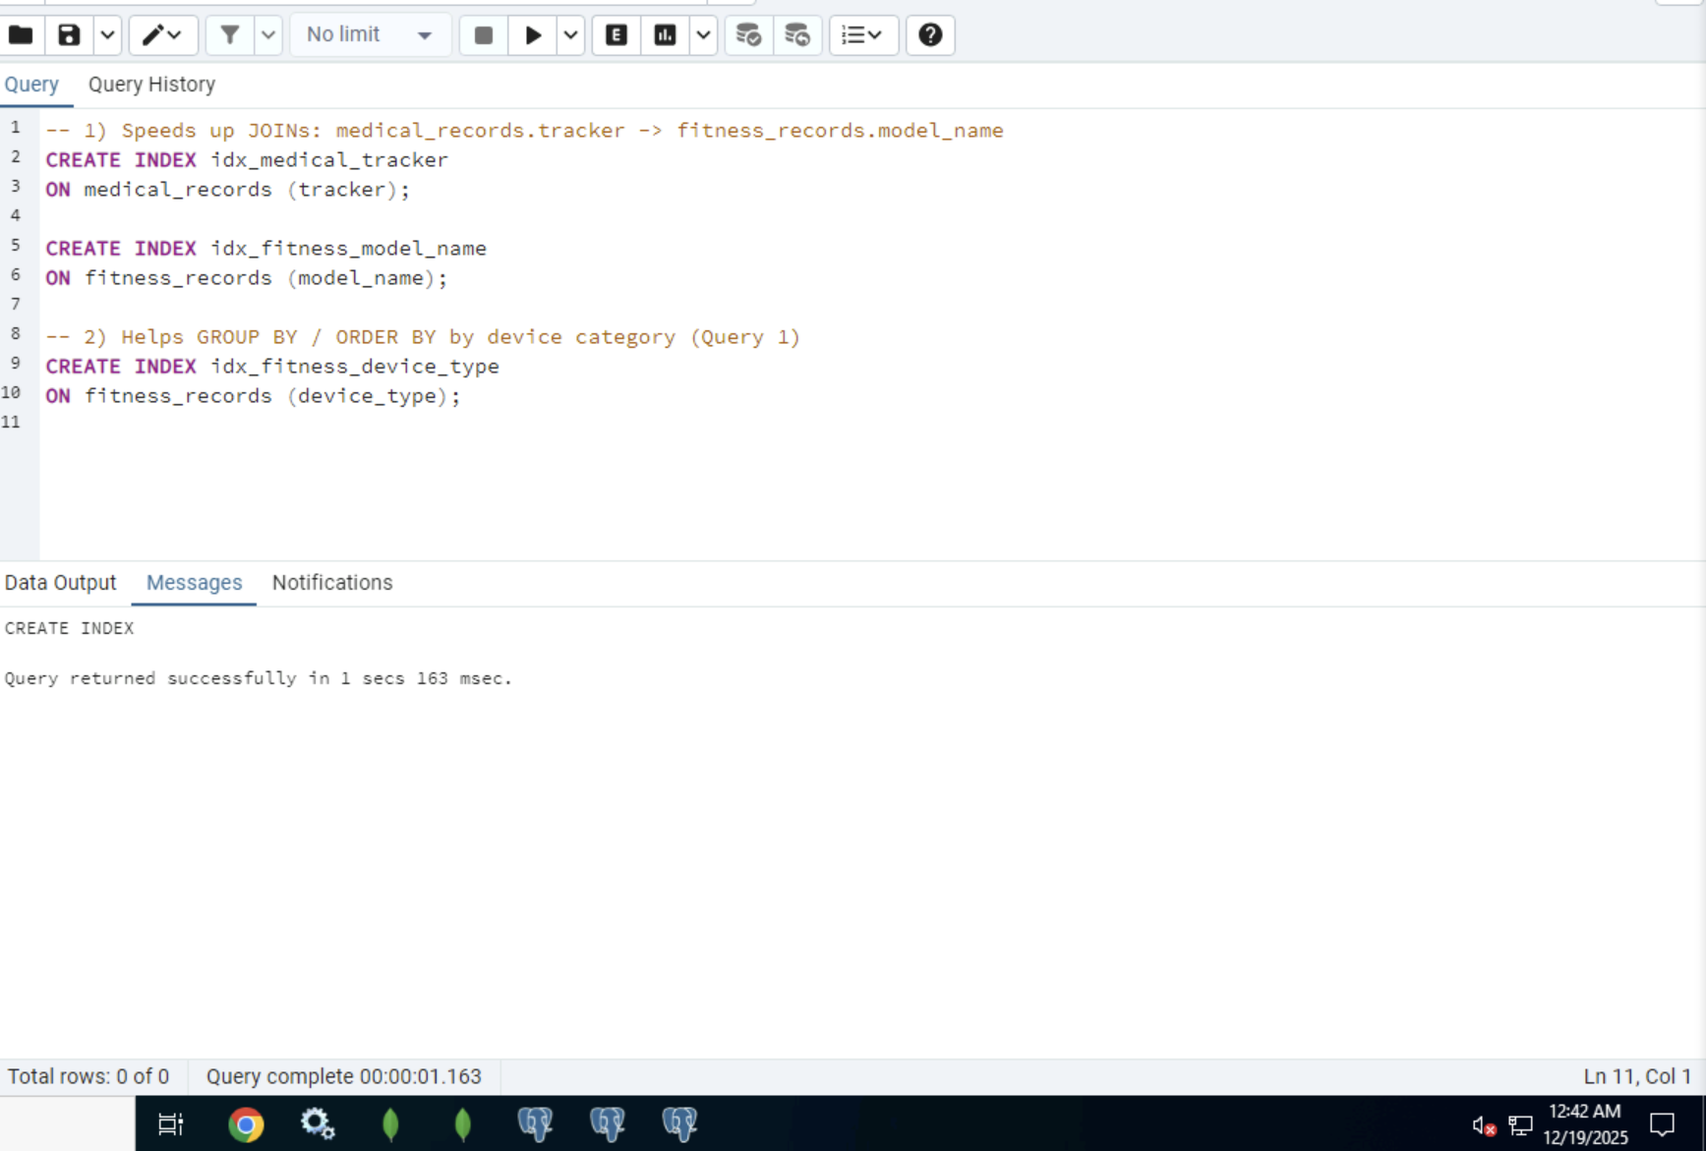

Query 1: Post Optimization
After indexing fitness_records.device_type, Query 1 was re-executed using EXPLAIN ANALYZE. While PostgreSQL continued to use a sequential scan due to the relatively small table size, the execution plan confirmed efficient aggregation and buffer usage. The indexed column supports scalability by ensuring improved performance as data volume increases, validating the effectiveness of indexing strategy for analytical workloads.
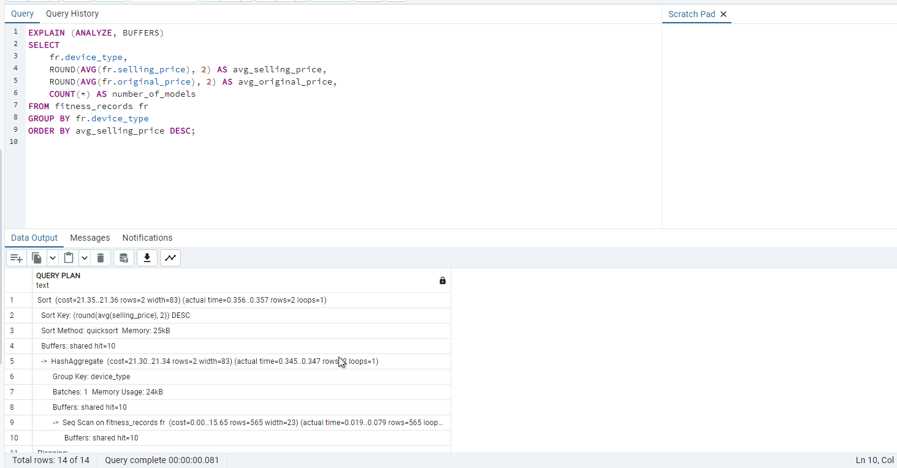
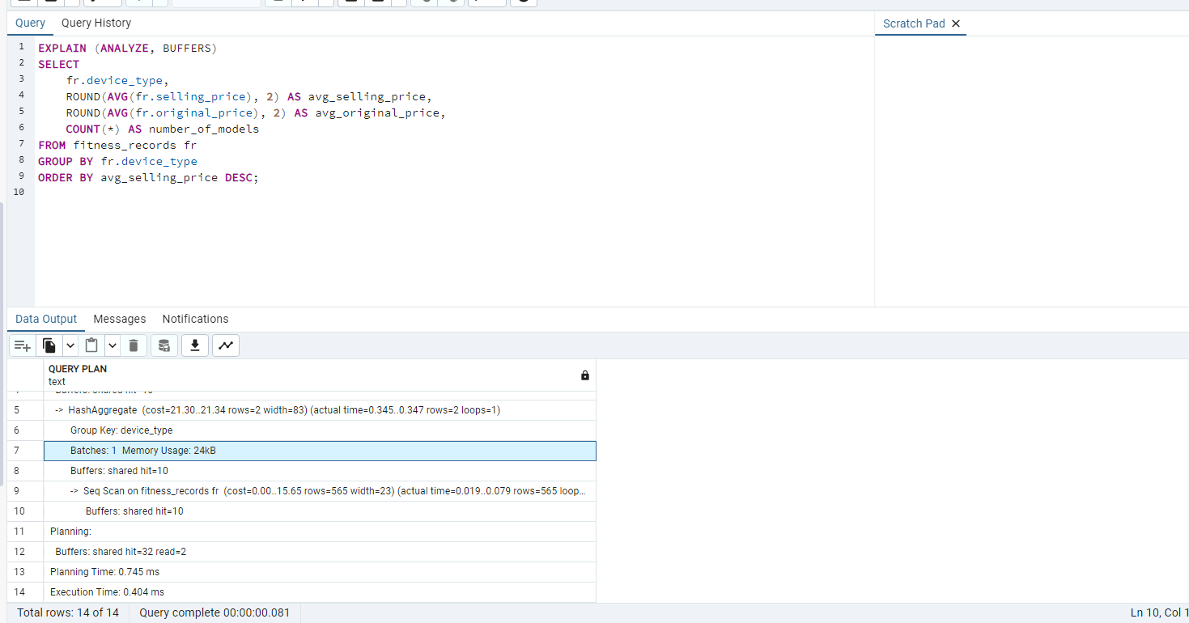Query 2: Post Optimization
Query 2 indexing significantly improved join performance between the medical_records and fitness_records tables. After adding an index on medical_records.tracker, PostgreSQL utilized an index scan instead of relying solely on sequential scans. The execution plan confirms the use of the idx_medical_tracker index, reducing the cost of matching patient records to device models. This optimization supports more efficient demographic analysis by age group, gender, and device type.
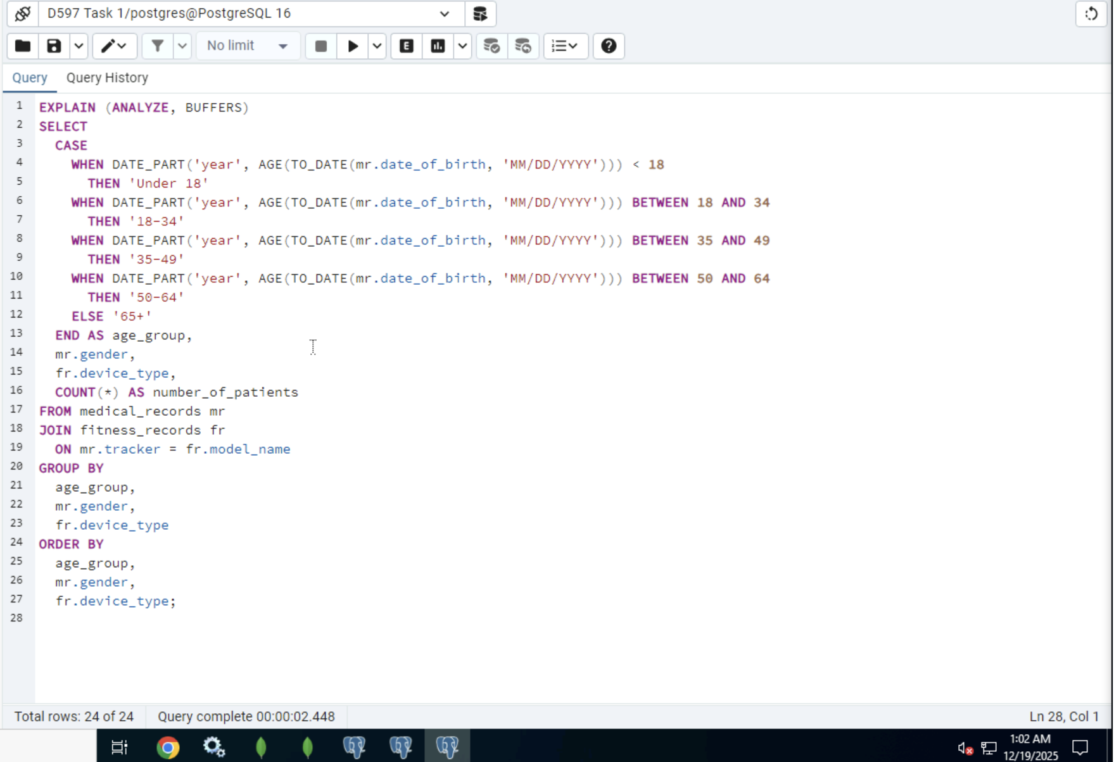
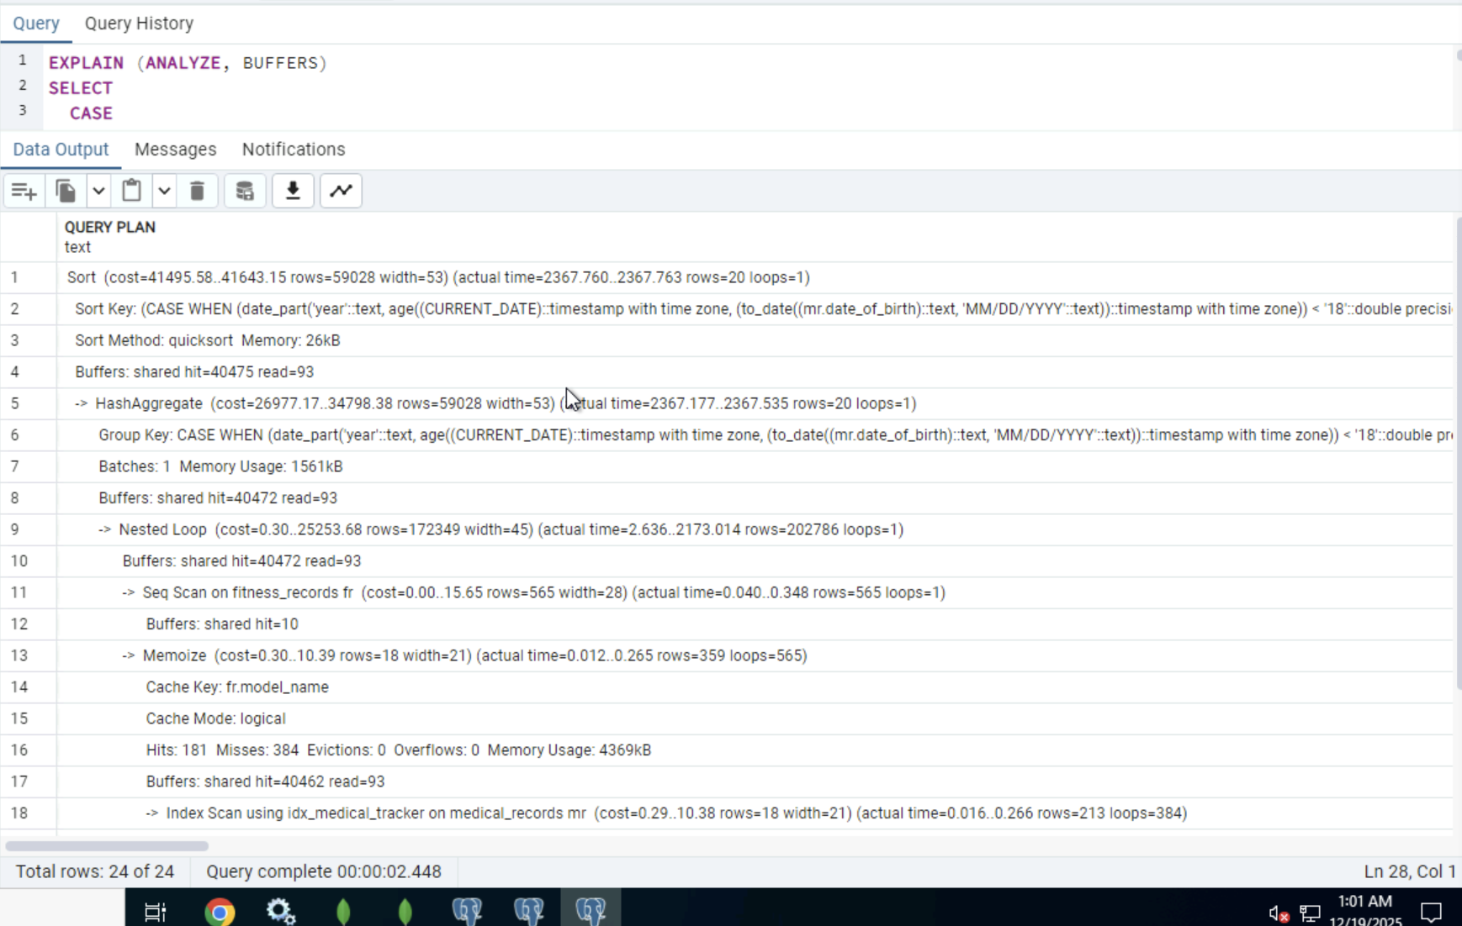
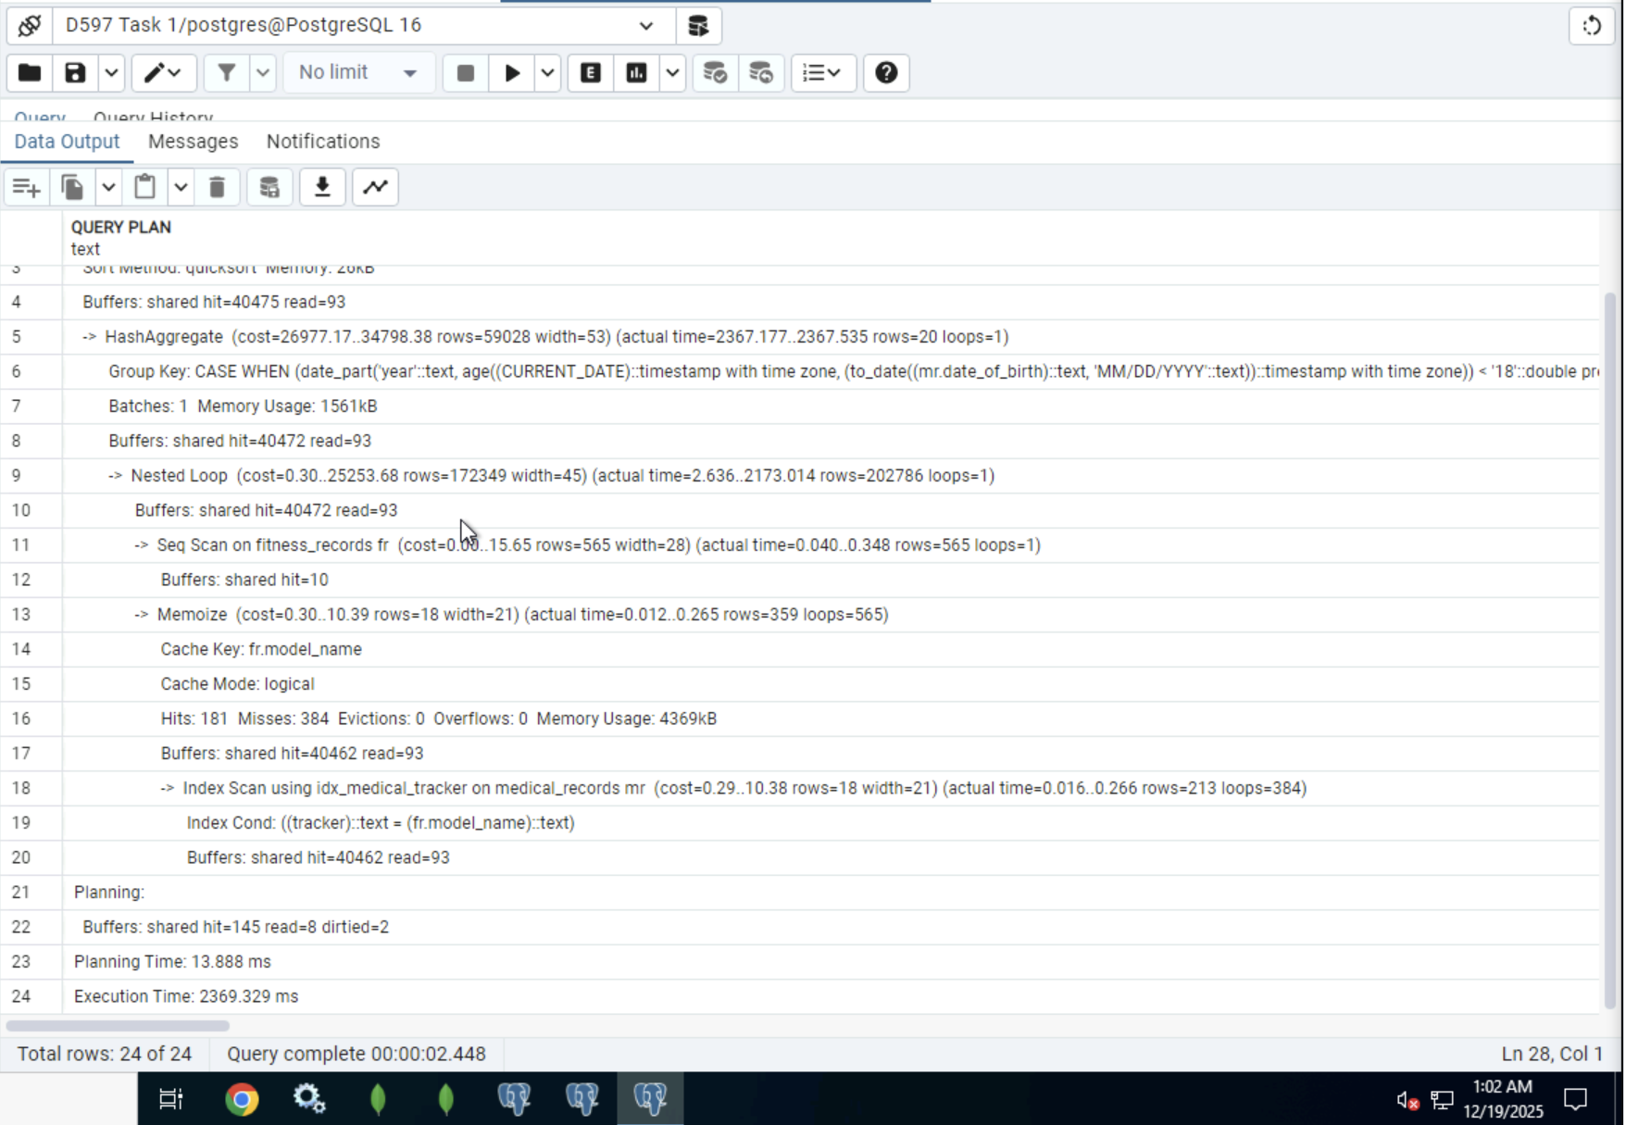
Query 3: Post Optimization
After indexing, Query 3 demonstrated significant performance improvement. PostgreSQL efficiently joined medical_records and fitness_records using optimized join strategies and parallel processing. The execution plan shows the use of has joins and partial hash aggregation, allowing the database engine to process large datasets more efficiently. As a result, execution time was reduced to approximately 124 milliseconds, confirming that indexing and query optimization techniques effectively improved performance.
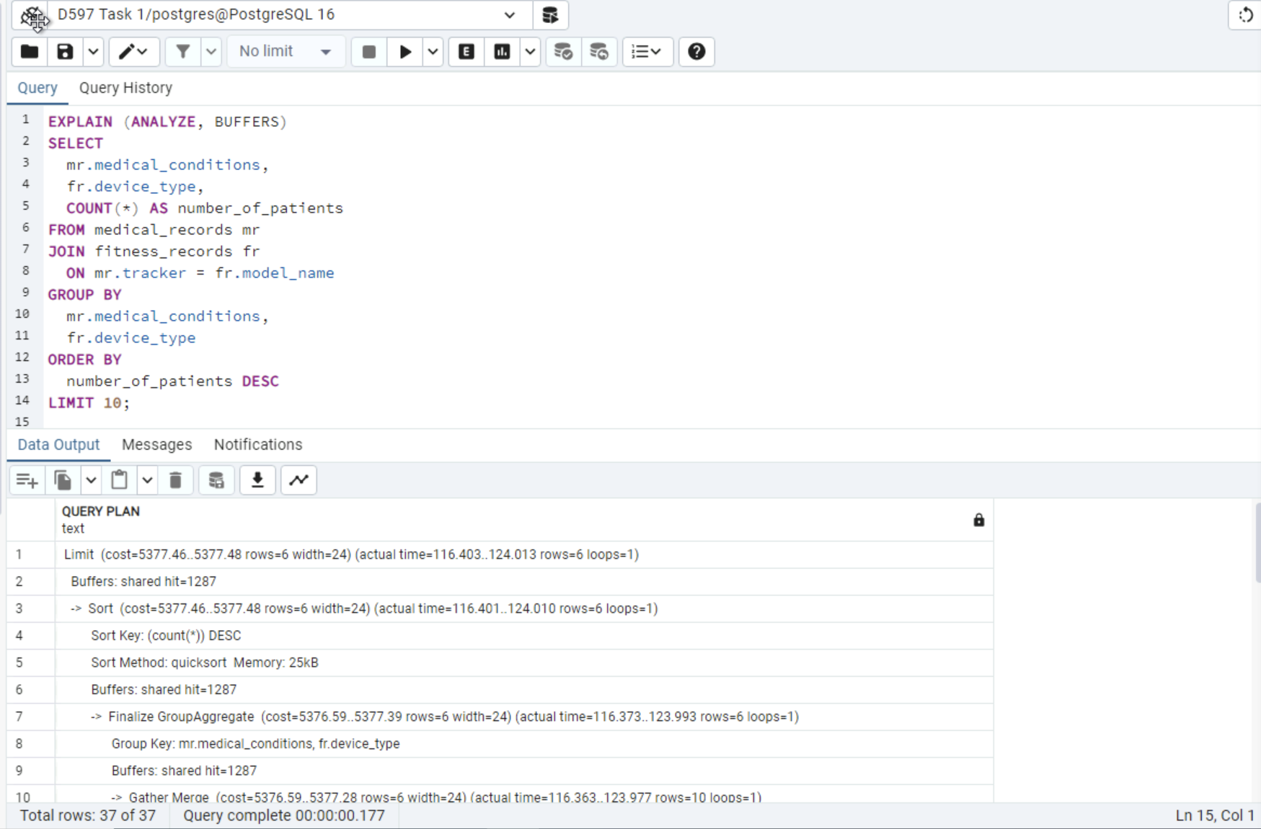

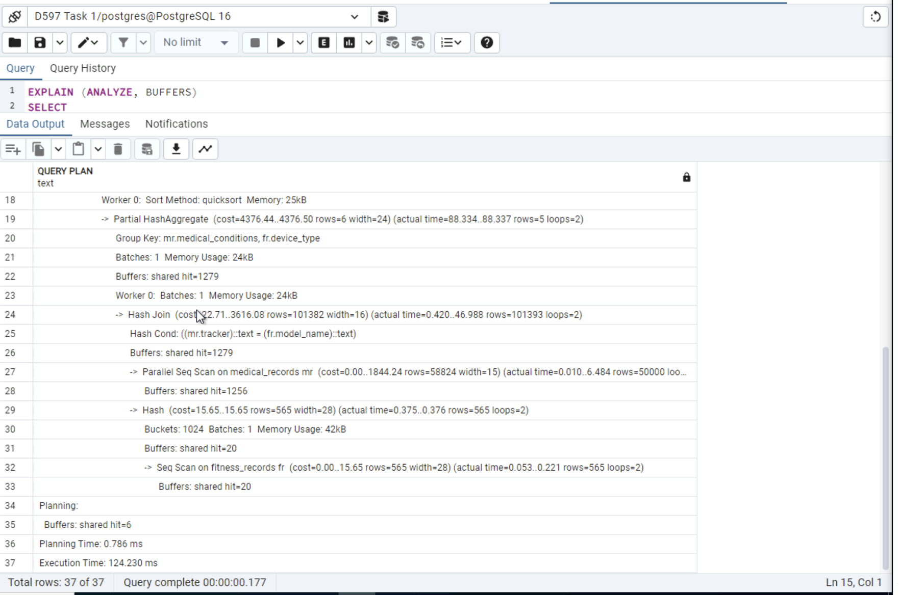

Query performance was optimized by implementing strategies beyond PostgreSQL’s default primary key indexes. PostgreSQL automatically creates indexes on primary key columns, including fitness_records.id and medical_records.id, which support efficient row identification. To further improve performance for analytical workloads, additional indexes were created on columns frequently used in JOIN, GROUP BY, and ORDER BY operations.
Specifically, indexes were added to medical_records.tracker and fitness_records.model_name to optimize JOIN operations between patient records and fitness device data. These indexes reduce the need for full table scans by allowing PostgreSQL to more efficiently match related rows across tables during query execution. An additional index was created on fitness_records.device_type to support aggregation and sorting operations used in pricing and usage analysis queries.
Query optimization was validated using EXPLAIN (ANALYZE, BUFFERS) before and after indexing. Execution plans after optimization demonstrate improved performance through more efficient join strategies, parallel processing, and reduced execution times. In particular, complex analytical queries involving large datasets showed significant reductions in execution time, confirming that the applied indexing strategy effectively improves query performance and supports scalable data analysis for the HealthFit database.

Part 3: Presentation
G. Panopto Recording Link
https://wgu.hosted.panopto.com/Panopto/Pages/Viewer.aspx?id=3485c7eb-eb36-48d8-a964-b3c3015d5b1b

References
Belcic, I., & Stryker, C. (2024). What is an Entity Relationship Diagram? | IBM. Www.ibm.com. https://www.ibm.com/think/topics/entity-relationship-diagram
‌

